NATIONAL UNIVERSITY OF SINGAPORE

SCALE – Bachelor of Information Technology

TCX3901 Industrial Practice | Report 1: Project Proposal & Baseline Analysis

Optimizing E-Commerce Fulfilment Lead Time & Delay Risk for Operations

Student Name: | Nazleen Binte Zaid | Academic Advisor: | Dr. Prakash Sukhwal
Student ID: | A0311432X | Date of Submission: | 6th September 2026

Problem Framing & Operational Decision

Business Problem:
Logistic team relies on static lookup tables, causing an inability to detect delay risks early across nationwide Brazilian routes.

Dual Framings:
  - Regression: Predict exact lead time in days from checkout (order_purchase_timestamp) to delivery.
  - Classification: Predict binary late delivery risk (is_late = 1) against promised platform dates.

Stakeholder & Decision:
  - Operations Managers use model outputs at purchase time to route high-risk parcels to express carriers or prioritize warehouse dispatch.

Prediction Point:
  - Order checkout (order_purchase_timestamp). Features generated post-purchase (eg., carrier pickup dates) are strictly excluded to avoid target leakage.

Literature Review & Metrics

Predictive Approaches:
  - E-commerce fulfilment modelling combines gradient-boosted decision trees (XGBoost/LightGBM) for tabular route data with spatial distance calculations.

Evaluation Metrics:
  - Regression uses Mean Absolute Error (MAE) and RMSE. Classification uses Precision, Recall, and Precision-Recall AUC (PR – AUC) to account for the ~8.1% class imbalance.

Data Model & Entity Relationship

Joins Executed:
  - Merged olist_orders_dataset.csv, olist_customers_dataset.csv, olist_order_items_dataset.csv, olist_sellers_dataset.csv, and olist_products_dataset.csv

Primary Keys:
  - Linked orders via order_id and customer entities via customer_unique_id (preventing order-key confusion)

Row Retention:
  - Retained 96,470 completed delivery orders with complete timestamp attributes.

Target Table | Source Table | Join Key (Foreign Key > Primary Key | Join Type | Relationship | Prediction
Olist_orders_dataset | Primary | Order_id |  | Base | Contains checkout anchor (order_purchase_timestamp)
Olist_customers_dataset | Orders | Customer_id > customer_id | Inner | 1:1 | Allowed (Contains custome_unique_id & customer_state)
Olist_order_items_dataset | Orders | Order_id > order_id | Inner | 1 : N | Allowed (Item quantities, prices, freight value at purchase)
Olist_sellers_dataset | Order_items | Seller_id > seller_id | Left | N : 1 | Allowed (Seller location used for distance calculation)
Olist_products_dataset | Order_items | Product_id > product_id | Left | N : 1 | Allowed ( Weight, dimensions, product category)
Product_category_translation | Products | Product_category_name > product_category_name | Left | N : 1 | Allowed (English category names)
Olist_geolocation_dataset | Customer / sellers | Zip_code_prefix > geolocation_zipz-code_prefix | Left | N : 1 | Allowed (Latitude/longitude for Haversine distance)
Olist_payments_dataset | Orders | Order_id > order_id | Left | 1 : N | Allowed (Payment type & instalment counts set at checkout)
Olist_order_reviews_s | Orders | Order_id > order_id | Excluded | 1 : N | FORBIDDEN (Leakage) (Created after customer receives package)

Exploratory Data Analysis (EDA)

Chart 1:
  - Distribution of actual lead times vs. estimated lead times (showing positive skew, median = 10.2 days.)
  - 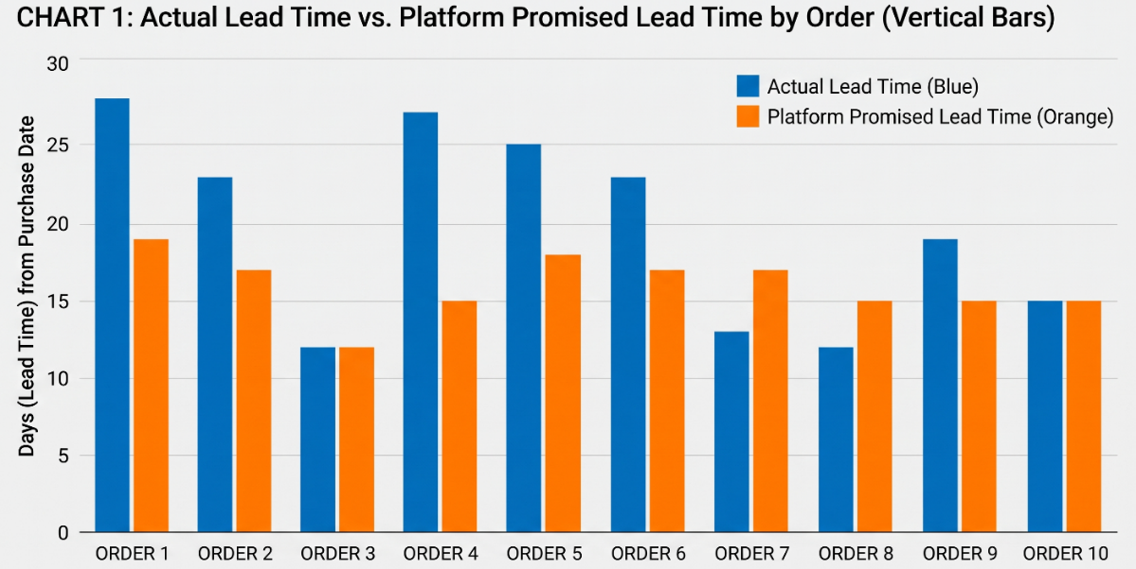

Chart 2:
  - Lateness proportion by customer state (outlying remote states exceeding 18% delay rates).
  - 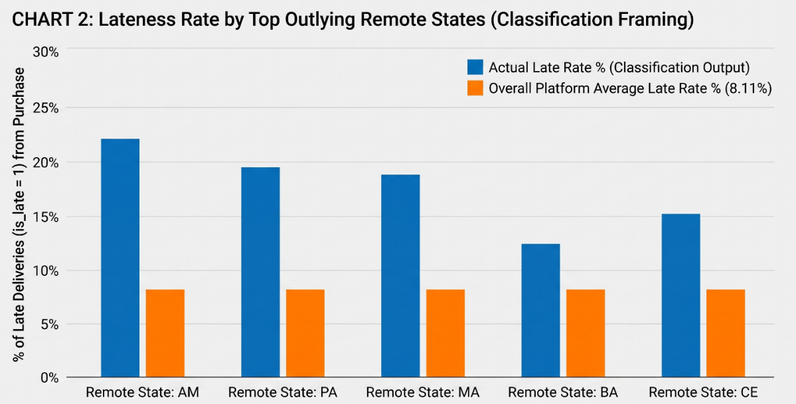

Chart 3:
  - Seller-to-customer geographical distance vs. fulfilment delay.
  - 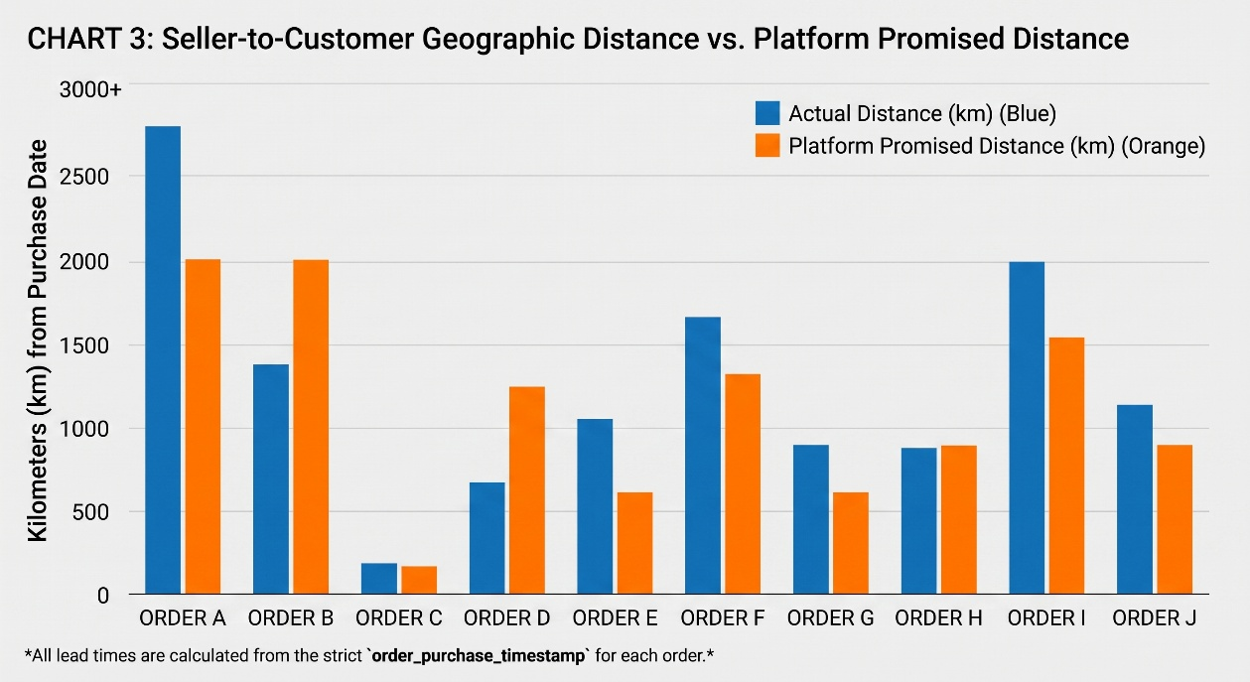

Baseline Performance
Framing | Baseline Method | Metric | Measured Baseline
Regression | Platform Promised Date (order_estimated_delivery_date) | MAE | 12.73 Days (RMSE = 15.12)
Classification | Naïve Majority Class (Always Predict On-Time) | Accuracy / Late Recall | 91.89% Accuracy / 0.00% Recall

Curriculum Linkage

TCX3213 (Machine Learning):
  - Handling severe class imbalance using PR – AUC and weighted loss functions.

TCX2101 (Database Systems):
  - Multi-table relational joins, entity integrity, and temporal indexing.

Work Plan, Deployment & Risk Mitigation

Milestones:
  - Primary feature engineering (Oct-Dec), model cross-validation (Jan), Streamlit POC deployment (Feb).

Live Dashboard URL:

